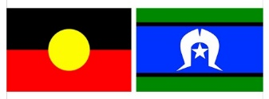
cr
Introduction to
Women with Disabilities Victoria’s
Youth Project Co-design Group

Who We Are:
Women with Disabilities Victoria is an organisation that focuses on the needs of women with disabilities.
We are also called WDV.
This form was written by WDV. When you see ‘we’ or ‘us’ in this form, it means WDV.

Our Leadership Program:
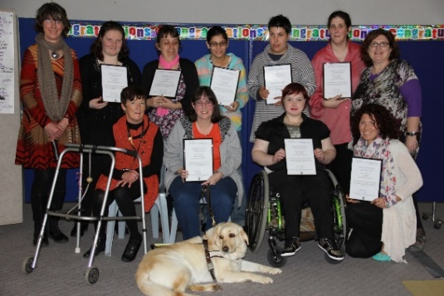
For 8 years, WDV has had a program called the Enabling Women Leadership Program, sometimes it is just called Enabling Women.
‘Enabling’ means supporting someone to have the power to do things themselves.

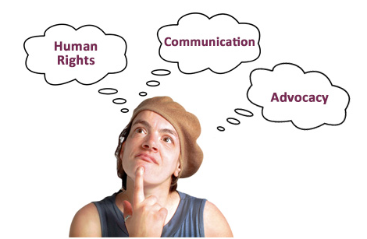
Enabling Women helps women with disabilities to develop knowledge and skills around leadership.
Topics include human rights, communication and advocacy. ‘Advocacy’ is when you speak up about your rights, and the rights of others.

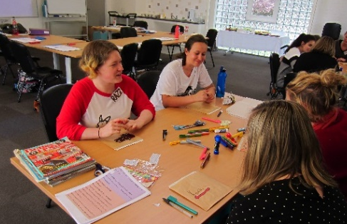
The Program helps participants:
- Learn about important issues
- Discuss important issues
- Be confident leaders in their community.

Our Program for Young Women:
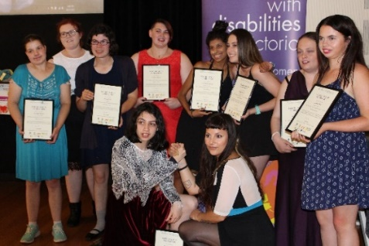
3 of the Enabling Women Leadership Programs have been for girls and young women, aged 15-25.
These Programs were good. But WDV wants to know how they could be better.

For example – what programs would help young people with disability who are girls, women, non-binary, gender diverse, and femme identifying, to become better leaders.
Co-Design Group:
WDV is starting a group to help us learn how we can support people to be better leaders.
The Group is called the Youth Project Co-Design Group.
Members of the group will be called Co-designers.

Co-designers will talk about ideas and why they are good or bad.

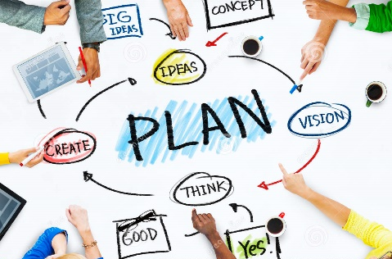
By working together the co-designers will create a plan for how WDV will support people to be strong leaders.
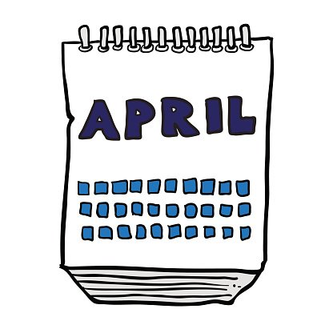
The Group will run from April – August this year.

How will the Co-design Group work?
The group will consist of up to 10 co- designers, and 2 WDV staff members.

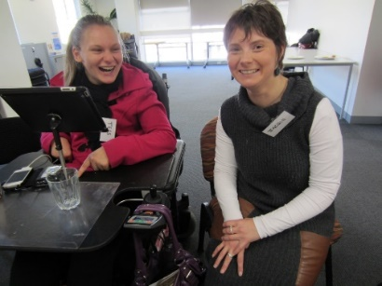
WDV will support co-designers with access needs. For example Easy English documents, or a support worker or interpreter to attend meetings with them.
People can tell us about their access needs in the Application form.
There is more information about the Application form at the end of this document.

The Co-design Group will run in 2 stages.
During Stage 1:
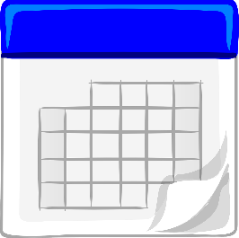
Group meetings will be once a week.
The group will meet online for a total of 8 times in Stage 1.

Co-designers will decide what day and time the group meets.
Meetings will run for 2 hours each time.
There will be plenty of breaks.
At home:
Some additional reading and thinking time will need to be done in between meetings.
This will be up to 1.5 hours a week.

Money:
Co-designers will be paid $25 per hour, for up to 7 hours a fortnight.
This is to say thank you for their time and work.

During Stage 1:
In Stage 1, the Co-Design Group will help make decisions for how Stage 2 will run.
Stage 2 will end by August 31st 2021.

Co-designers:
Co designers will be interested in helping design what leadership opportunities should be for girls and women with disabilities.
Co-designers will also be willing to share ideas, and give feedback.

Co-designers must:

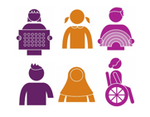
- Be aged 15-25
- Be a girl/woman (cis or trans), trans boy/man, or a person who is non-binary, genderqueer, femme identifying.
- Feel comfortable in a space for women
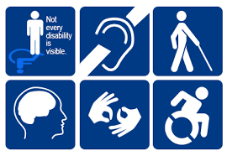
- Be someone:
- with disability (physical, sensory, intellectual, cognitive, etc.),
- who is Deaf / deaf / hard of hearing,
- who lives with chronic illness, and/or pain,
- who is neurodiverse. For example; autistic,
- who lives with mental health challenges.

Past Experience:
Co-designers may, or may not have certain experiences

They may have a high level of education.
Or may not have any level of education.

They may have experience with co-design groups, working groups, or committees.
Or may not have experience with these things.

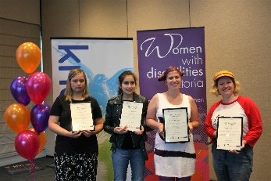
They may have participated in previous leadership groups.
Or may not have participated in any leadership groups.
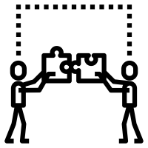
Either way is okay.
WDV wants a mix of people who hand and do not have experience in these things.

Background:
People from diverse backgrounds are encouraged to apply.
For example, if you are
- Aboriginal or a Torres Strait Islander
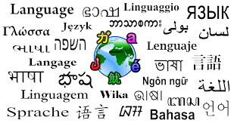
- LGBTQIA+,
- Someone who speaks a language other than English at home
- A person of colour
- Someone who lives in regional or rural Victoria
Victoria

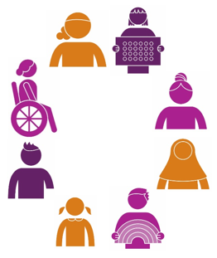
WDV aims to have members with wide ranging experiences and knowledge that can be represented and shared.
So everyone is welcome!

How to apply:
If you want to be a member of the group you will need to apply
There is an Application form to do this.
You can complete the Application form in multiple ways:

- Complete the application form electronically or by hand, and email it to Bridget Jolley at WDV – youth@wdv.org.au

- Complete the application in a video or audio recording, and send it using WeTransfer or Dropbox.
Please refer to Sharing information via WeTransfer and Dropbox for how to do this.
Please contact Bridget at WDV to let us know that you have applied in a video / audio recording.
Contact details:
Phone – 03 9286 7813, or
Email – youth@wdv.org.au

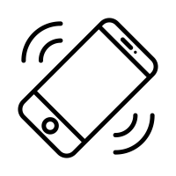
- Contact Bridget Jolley at WDV to assist you to complete the application Phone – 03 9286 7813, or
Email – youth@wdv.org.au

You can also ask someone that you trust to help you complete and send the application form.

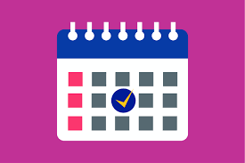
Applications close on Thursday April 22, at 9am.

For further information and assistance
Please contact Bridget Jolley at WDV
- For further information
- For assistance to complete an application form
- To advise you have applied using WeTransfer or Dropbox,

You can contact Bridget by
Phone – 03 9286 7813, or
Email – bridget.jolley@wdv.org.au,
Application Form for the
Youth Project Co-design Group

Application Details
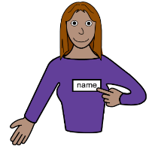
Name:
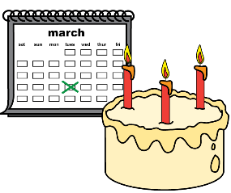
Date of birth:
Email:
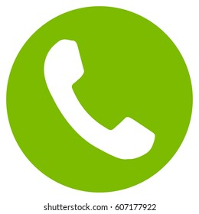
Phone:

Address:
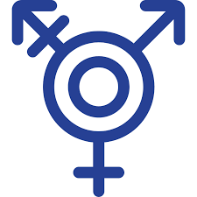
Gender:

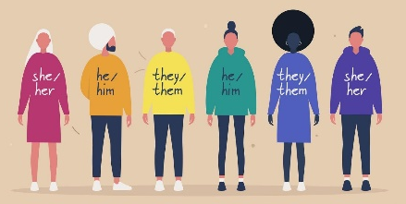
Pronouns.
(For example she/her, they/them, he/him. Or prefer not to say):
What is the nature of your disability/disabilities?

Do you identify as LGBTQIA+? Yes / No / Prefer not to say.
If yes, please feel free to give further information (Optional):

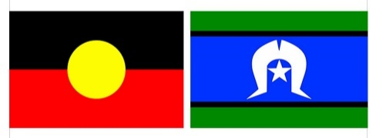
Do you identify as being of Aboriginal/Torres Strait Islander origin? Yes / No / Prefer not to say.
If yes, please feel free to give further information (Optional):

Do you identify as being from a Culturally and Linguistically Diverse (CALD) background?
Yes / No / Prefer not to say.
If yes, please feel free to give further information (Optional):

What are your interests and hobbies?

Have you participated in working groups, advisory groups, co-design groups, etc. before?
It is okay if you have not. If yes, please give details:

Have you participated in leadership programs or events before?
It is okay if you have not. If yes, please give details:

Why do you want to be part of this Co-design group?

What skills, knowledge, or strengths do you have that will help the group?

If this group met virtually (online), do you need any technology or other supports to support you?

Do you find any online meeting platforms inaccessible?
If yes, please give details:

What supports do you need to have so you can fully participate?
For example: Auslan interpreter, captions, audio description of images and videos, information in plain or easy English, a support worker, lots of breaks.

We hope to have most of our meetings for Stage 1 of the Co-design group completed before July 2021. Please select what days and times you think you will usually be available between now and 30th July 2021.
Weekends
Saturday: Morning Afternoon Evening
Sunday: Morning Afternoon Evening
Weekdays
Monday: Morning Afternoon Evening
Tuesday: Morning Afternoon Evening
Wednesday: Morning Afternoon Evening
Thursday: Morning Afternoon Evening
Friday: Morning Afternoon Evening

Would you like to provide further information about these days and times?
For example, I am available on weekday afternoons after 4pm. Or, I am not available on Sunday mornings before 11am.

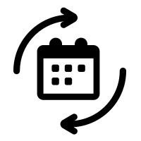
We know that sometimes it is hard to know your availability months in advance. Do you think your availability is likely to change much between now, and 30th July 2021?
Yes / No / Unsure / Prefer not to say.
If yes or unsure, please give details:

Are there any periods of time that you know you will be unavailable?
For example, I am away on holidays 15th June – 22nd June.

Is there anything you would like to add to your application, or you would like us to know about?

Thank you for your application!

