2019 Brenda Gabe Leadership Award

Celebrating Women with Disabilities

About the Award | Find out more here:  www.wdv.org.au/BrendaGabeAward
The Brenda Gabe Leadership Award is a biennial award which recognises and rewards outstanding leadership from women with disability in Victoria.

Women with Disabilities Victoria (WDV) invites nominations of individuals or groups who have made a contribution which has either:
- Directly benefited women with disability, or
- Ensured a more inclusive community for women with disability.

Eligibility
Individuals (or groups) nominated for this award must be:
- A woman (or women) with disability
- Residents of Victoria.
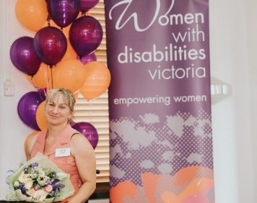
You can nominate:
- Yourself or your group, or
- Another individual woman or group.

We encourage the nomination of women with diverse backgrounds and/or life experiences.

Nomination Period  Nominations open: 3 June 2019  Nominations close: 3 September 2019 | Jenny Godwin, the 2017 recipient of the Brenda Gabe Leadership Award.

The 2019 Brenda Gabe Leadership Award announcement
The recipient of the award will be announced at WDV’s Annual General Meeting on 21 November 2019 and will receive a $2,000 prize towards professional development or a capacity-building project.

The recipient will be required to provide:
- A proposal for use of the award money
- A demonstration of the use of the award money, including a report, by November 2020.

To nominate or find out more
To find out more about the award, including how to nominate and details about previous nominees and recipients, please visit:
W www.wdv.org.au/BrendaGabeAward

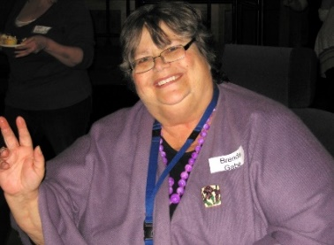
If you would like more information about nominating for this year’s award please contact Elyse Cox:
P (03) 9286 7800
E elyse.cox@wdv.org.au

About Brenda Gabe
Brenda Gabe became a devoted disability advocate after being diagnosed with multiple sclerosis in 1994. The dedicated mother, psychologist and former champion swimmer was a much-loved member of WDV who represented the organisation on multiple committees and forums. Brenda worked tirelessly on many advocacy campaigns including accessible housing and transport, as well as gender and disability related campaigns, including preventing violence against women with disability.

Acknowledgement
WDV gratefully acknowledges the significant contribution and support provided by Dr. Helen Sykes AM, Director of Future Leaders, in making this award possible.

