Youth Project Co-design Group

Women with Disabilities Victoria is seeking members for a Co-design group, who will discuss ideas and help design leadership opportunities.

Members of the group will:
- Be aged 15-25
- Be a girl/woman (cis or trans), non-binary, gender diverse, or femme identifying person comfortable in a space for women
- Be someone
  - with disability (physical, sensory, intellectual, cognitive, etc.)
  - who is Deaf / deaf / hard of hearing,
  - who lives with chronic illness, and / or pain,
  - who is neurodiverse, e.g. autistic,
  - who lives with mental health challenges.

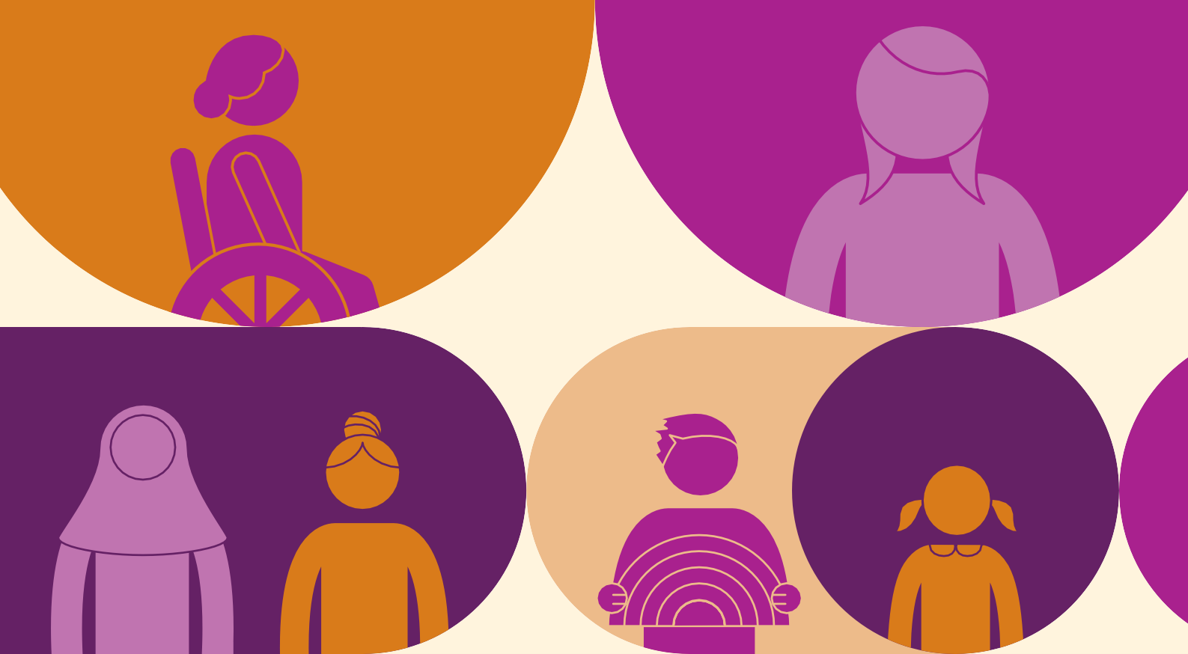

Details
What: Attending online meetings and some work outside of meetings
Date: April – August 2021
Time: Up to 3.5 hours a week
Location: Online / at home
For more information: https://www.wdv.org.au/our-work/youthprojects/
Contact: Bridget Jolley on (03) 9286 7800 or at youth@wdv.org.au.

